Systems Analysis

and Design

Instructor : Huang, Chuen-Min

**Teamwork ver.1**

Group 9

|  |  |
| --- | --- |
| ID | Name |
| A10523013  B10423013 | Miko  Tiffany |
| B10423038 | John |
| B10423041 | Dan |
| B10523009 | Jerry |
| B10523024 | Steven |
| B10523048 | Andy |
| B10523062  B10523063 | Ken  Patrick |
|  |  |
| Date 2018/05/07 | |

**Directory**

1.Describe the project： 2

2.Use case diagram： 3

3.Use case description： 4

4Activity diagram： 6

5.Sequence diagram： 7

6.Class Diagram： 9

7.Behavior state machine： 10

8.Teamwork Responsibility： 11

# 1.Describe the project：

There is always a huge line of people waiting for the famous restaurants, so how can they make the customers to have the seats without being a mess. Therefore, we create a great work of genius call “Arrange table system”. This system shows the states of all table with different colours, like the white shows “empty”, the green shows “started”, the yellow shows “reserved”, and the red shows “notified”.

Let’s walk through this scenario, at first the receptionist will ask for the reservation, if it does, then receptionist will check the information (phone number , people and time), if it’s all correct as well as all of people are present, the receptionist will take them to their table, change the table of the table to “started” and start to calculate the time. When the time is about to over, the table will go to “notified”, and then the server will come to notify the customers the time is almost over. If the customers finish their meal and leave the restaurant, the server will clean the table, then change the state of the table to “empty” which is the basic state of the table, and then receptionist will take the next customers to the table again. That is the first scenario.

Second comes when the customers have no reservation, the receptionist will check there is any table available. If there is a table, then the receptionist will take the customer to the table directly. But sadly, if there’s not, the receptionist will ask the customers politely “would you like to wait?”. If the customers want to wait in line, they have to fill in the information and keep waiting. When the table is up, the receptionist will call up the customers that they are good-to-go. If the customer does not want to wait again, the system will show the next queening data.

Last, if there is no reservation, no table, and the customer does not want to wait, the system ends

# 2.Use case diagram：

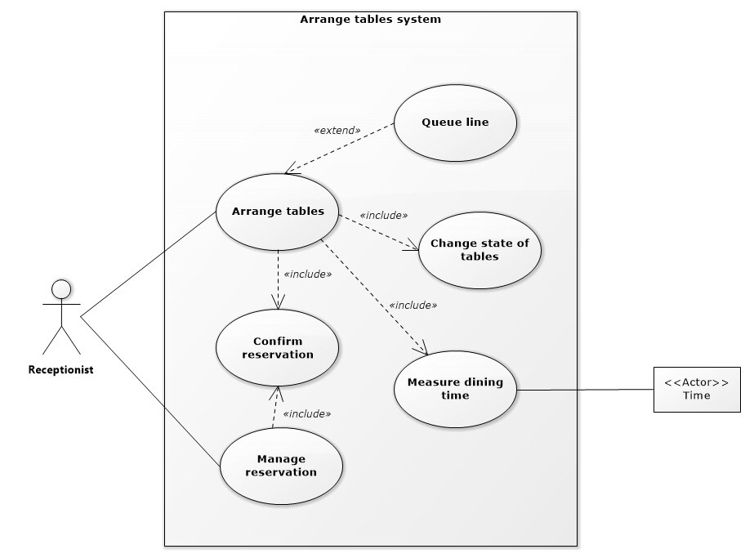

# 3.Use case description：

|  |  |  |  |
| --- | --- | --- | --- |
| **Use Case Name：**Arrange table | **ID**：1 | | **Importance Level：**High |
| **Primary Actor：**Receptionist | | **Use Case Type：**Detail, Essential | |
| **Stakeholders and Interests：**Receptionist：help customers to arrange table | | | |
| **Brief Description：**Make the customers have a table successfully. | | | |
| **Trigger：**When customers come to restaurant or they reserve.  **Type：**External | | | |
| **Relationships：**  **Association：**Receptionist  **Include：**  **Extend：**Queue, Reservation  **Generalization：** | | | |
| **Normal Flow of Events：**   1. Receptionist asks for the reservation.   If customers have reservation, go to step 2.  If customers have no reservation, go to S.1.   1. Receptionist checks that the reservation exists.   If the reservation exists, go to step 3.  If the reservation does not exist, go to step S.1.   1. Receptionist starts to calculate the time and changes the state to “started”. 2. Receptionist notifies the customers if the dining time is 10 minutes remaining and changes the state to “notified”. 3. When customers finish meal and reception receives “clean up” message, the table state will   change into “empty”. | | | |
| **SubFlows：**  S.1 Receptionist checks the available table  If it is full, go to S.1.1.  If it is not full, go to step 3.  S.1.1 Does the customer want to queue  If yes, go to S.1.1.1.  If no, go to S.2.  S.1.1.1 Fill in a personal information (Name, Phone number, Number of people),  go to S.1.1.2.  S.1.1.2 Add to Queue data, go to S.1.1.3.  S.1.1.3 Receptionist checks the available table.  If it is full, go to S.1.1.3.  If it is not full, go to S1.2.  S.1.2 Receptionist makes a call and confirms the reservation.  If take the table, go to step 3.  If not take the table, go to S.2.  S.2 Customers don’t want to wait or cancel waiting, the system ends. | | | |
| **Alternate/Exceptional Flow：** | | | |

# 4Activity diagram：

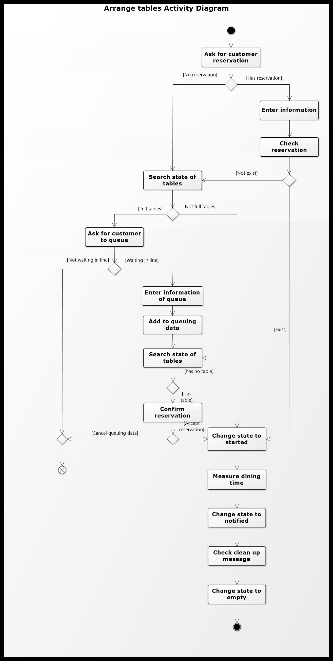

# 5.Sequence diagram：

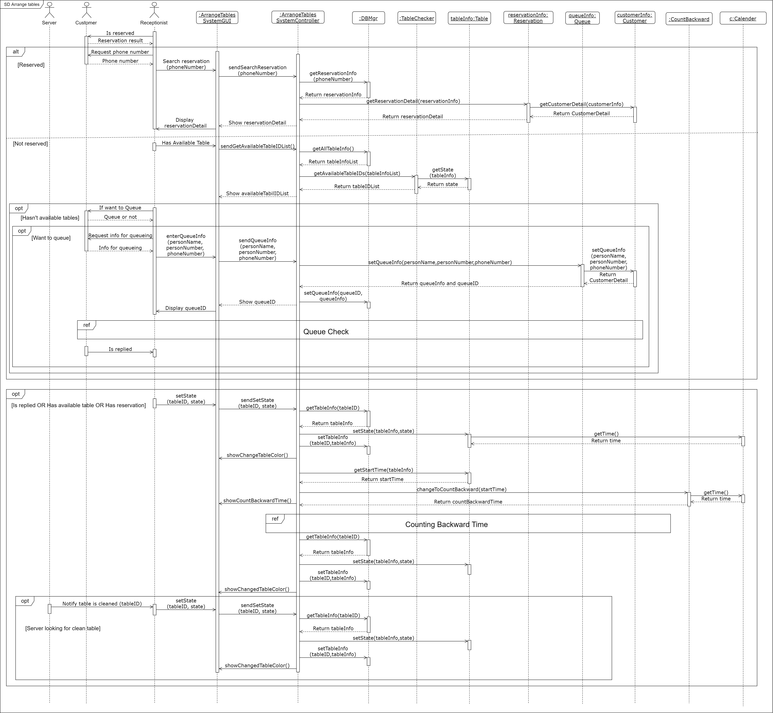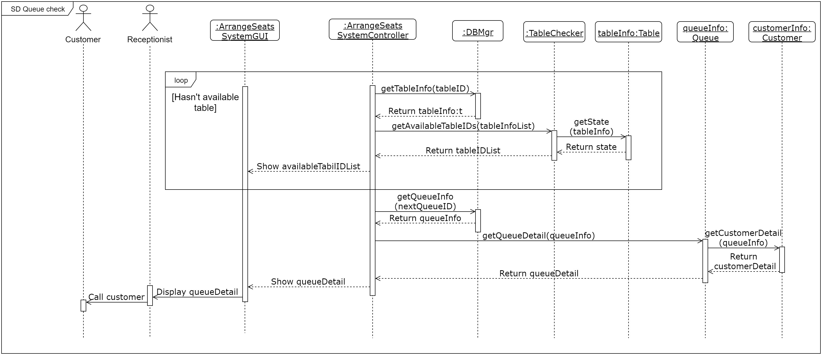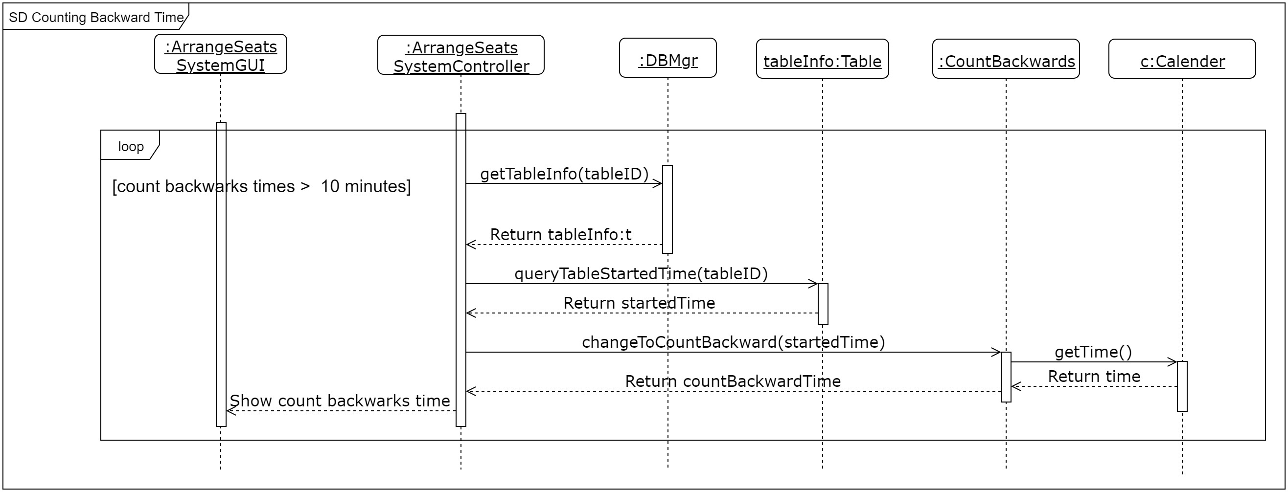

# 6.Class Diagram：

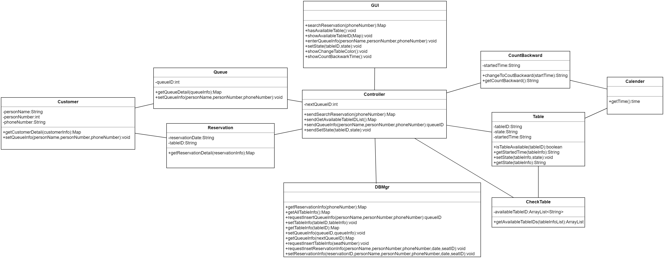

# 7.Behavior state machine：

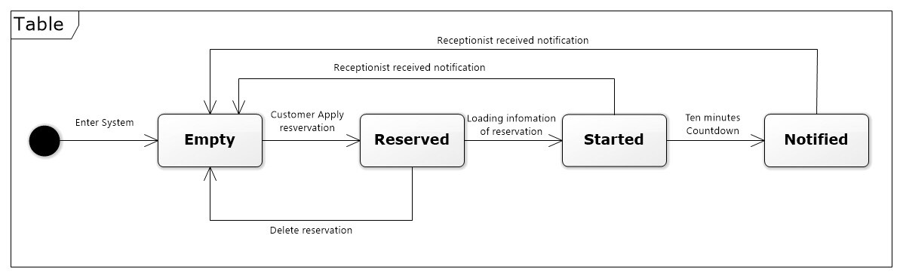

# 8.Teamwork Responsibility：

|  |  |  |  |
| --- | --- | --- | --- |
| ID | Name | Responsibility | Percentage |
| A10523013 | Miko | Integrate document | 100% |
| B10423013 | Tiffany | Draw sequence diagram, class diagram | 100% |
| B10423038 | John | System description | 85% |
| B10423041 | Dan | Draw use case diagram, activity diagram, Behavior state machine diagram | 100% |
| B10523009 | Jerry | Use case description | 95% |
| B10523024 | Steven | Use case description | 85% |
| B10523048 | Andy | Translate document, Behavior state machine diagram | 85% |
| B10523062 | Ken | Use case diagram | 85% |
| B10523063 | Patrick | N/A | 0% |